9.ReactJS-HQL

Create a React Application named “cricketapp” with the following components:

App.jsx

import React, { useState } from 'react';

import ListofPlayers from './ListofPlayers';

import Scorebelow70 from './Scorebelow70';

import OddPlayers from './OddPlayers';

import EvenPlayers from './EvenPlayers';

import ListofIndianPlayers from './ListofIndianPlayers';

import { IndianPlayers } from './PlayersData';

const players = [

  { name: 'Jack', score: 50 },

  { name: 'Michael', score: 70 },

  { name: 'John', score: 40 },

  { name: 'Ann', score: 61 },

  { name: 'Elisabeth', score: 61 },

  { name: 'Sachin', score: 95 },

  { name: 'Dhoni', score: 100 },

  { name: 'Virat', score: 84 },

  { name: 'Jadeja', score: 64 },

  { name: 'Raina', score: 75 },

  { name: 'Rohit', score: 80 }

];

function App() {

  const [flag, setFlag] = useState(true);

  const IndianTeam = ["Sachin1", "Dhoni2", "Virat3", "Rohit4", "Yuvaraj5", "Raina6"];

  return (

    <div>

      <button onClick={() => setFlag(!flag)}>

        {flag ? 'Show Indian Team View' : 'Show Score View'}

      </button>

      <hr />

      {flag ? (

        <div>

          <h1> List of Players</h1>

          <ListofPlayers players={players} />

          <hr />

          <h1> List of Players having Scores Less than 70 </h1>

          <Scorebelow70 players={players} />

        </div>

      ) : (

        <div>

          <h1> Indian Team </h1>

          <h1> Odd Players </h1>

          <OddPlayers players={IndianTeam} />

          <hr />

          <h1> Even Players</h1>

          <EvenPlayers players={IndianTeam} />

          <hr />

          <h1> List of Indian Players Merged:</h1>

          <ListofIndianPlayers IndianPlayers={IndianPlayers} />

        </div>

      )}

    </div>

  );

}

export default App;

EvenPlayers.jsx

import React from 'react';

function EvenPlayers({ players: [, second,, fourth,, sixth] }) {

  return (

    <div>

      <li> Second : {second} </li>

      <li> Fourth : {fourth} </li>

      <li> Sixth : {sixth}</li>

    </div>

  );

}

export default EvenPlayers;

index.js

import React from 'react';

import ReactDOM from 'react-dom/client';

import App from './App';

const root = ReactDOM.createRoot(document.getElementById('root'));

root.render(<App />);

ListofIndianPlayers.js

import React from 'react';

function ListofIndianPlayers({ IndianPlayers }) {

  return (

    <div>

      {IndianPlayers.map((item, index) => (

        <li key={index}> Mr. {item} </li>

      ))}

    </div>

  );

}

export default ListofIndianPlayers;

ListofPlayers.js

import React from 'react';

function ListofPlayers({ players }) {

  return (

    <div>

      {players.map((item, index) => (

        <li key={index}>

          Mr. {item.name} <span> {item.score} </span>

        </li>

      ))}

    </div>

  );

}

export default ListofPlayers;

OddPlayers.js

import React from 'react';

function OddPlayers({ players: [first,, third,, fifth] }) {

  return (

    <div>

      <li> First : {first} </li>

      <li> Third : {third} </li>

      <li> Fifth : {fifth}</li>

    </div>

  );

}

export default OddPlayers;

PlayersData.js

const T20Players = ['First Player', 'Second Player', 'Third Player'];

const RanjiTrophyPlayers = ['Fourth Player', 'Fifth Player', 'Sixth Player'];

export const IndianPlayers = [...T20Players, ...RanjiTrophyPlayers];

Scorebelow70.js

import React from 'react';

function Scorebelow70({ players }) {

  const players70 = [];

  players.map((item) => {

    if (item.score <= 70) {

      players70.push(item);

    }

  });

  return (

    <div>

      {players70.map((item, index) => (

        <li key={index}>

          Mr. {item.name} <span> {item.score} </span>

        </li>

      ))}

    </div>

  );

}

export default Scorebelow70;

Output-

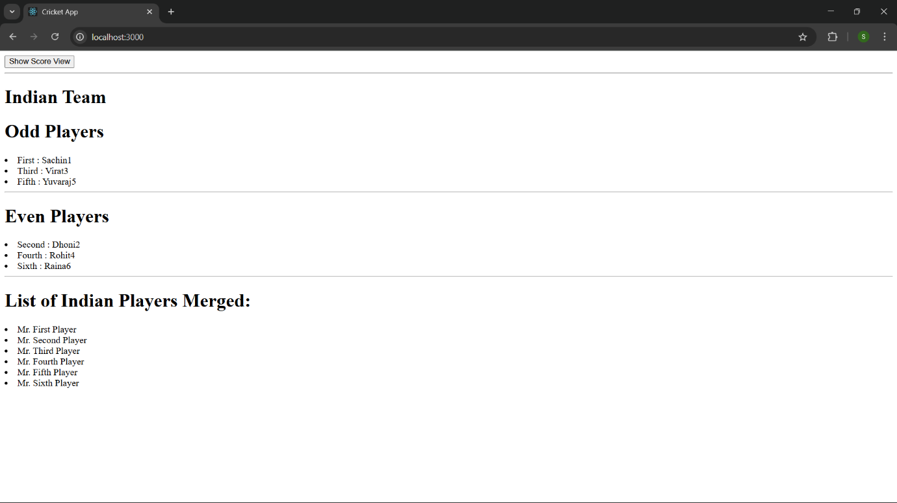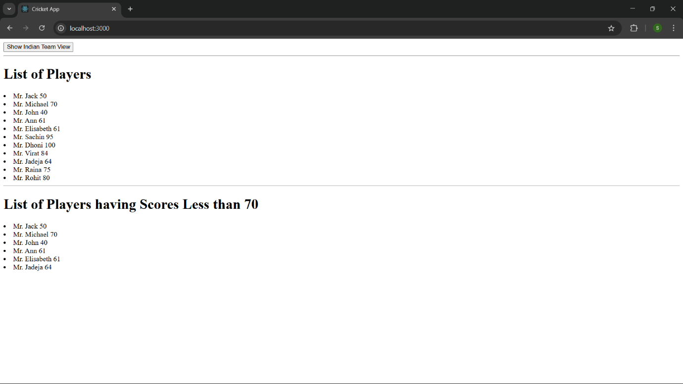

10.ReactJS-HQL

Create a React Application named “officespacerentalapp” which uses React JSX to create elements, attributes and renders DOM to display the page.

App.js

import React from 'react';

import './index.css';

function App() {

  const offices = [

    {

      name: 'DBS',

      rent: 50000,

      address: 'Chennai',

      image: 'https://www.dbsindia.com/images/banner/banner4.jpg'

    },

    {

      name: 'Regus',

      rent: 75000,

      address: 'Bangalore',

      image: 'https://www.regus.com/images/office.jpg'

    },

    {

      name: 'WeWork',

      rent: 60000,

      address: 'Mumbai',

      image: 'https://www.wework.com/images/mumbai.jpg'

    }

  ];

  return (

    <div style={{ padding: '20px' }}>

      <h1><b>Office Space , at Affordable Range</b></h1>

      {offices.map((office, index) => {

        const rentColor = office.rent <= 60000 ? 'textRed' : 'textGreen';

        return (

          <div key={index} className="office-container">

            <img src={office.image} alt={office.name} className="office-image" />

            <h2>Name: {office.name}</h2>

            <p className={rentColor}>Rent: Rs. {office.rent}</p>

            <p><b>Address:</b> {office.address}</p>

            <hr />

          </div>

        );

      })}

    </div>

  );

}

export default App;

index.css

.textRed {

  color: red;

  font-weight: bold;

}

.textGreen {

  color: green;

  font-weight: bold;

}

.office-container {

  margin-bottom: 30px;

}

.office-image {

  width: 300px;

  height: auto;

}

Index.js

import React from 'react';

import ReactDOM from 'react-dom/client';

import './index.css';

import App from './App';

const root = ReactDOM.createRoot(document.getElementById('root'));

root.render(<App />);

Output-

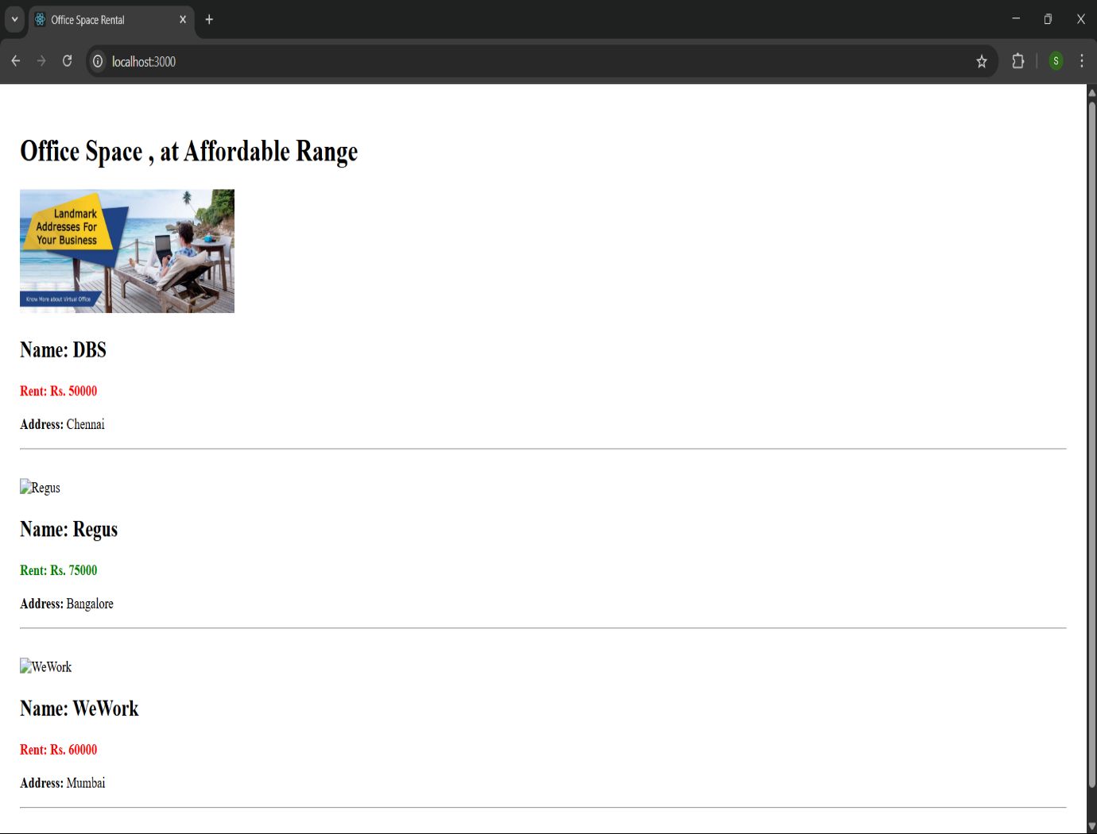

ReactJs-HQL – 11

Create a React Application “eventexamplesapp” to handle various events of the form elements in HTML.

App.js

import React, { useState } from 'react';

import CurrencyConvertor from './CurrencyConvertor';

function App() {

const [count, setCount] = useState(5);

const increment = () => {

setCount(prev => prev + 1);

sayHello();

staticMessage();

};

const decrement = () => {

setCount(prev => prev - 1);

};

const sayHello = () => {

console.log("Hello!");

};

const staticMessage = () => {

console.log("Increment button clicked!");

};

const sayWelcome = (message) => {

alert(message);

};

const handleClick = (e) => {

alert("I was clicked");

};

return (

<div style={{ padding: "20px" }}>

<h3>{count}</h3>

<button onClick={increment}>Increment</button><br /><br />

<button onClick={decrement}>Decrement</button><br /><br />

<button onClick={() => sayWelcome("welcome")}>Say welcome</button><br /><br />

<button onClick={handleClick}>Click on me</button><br /><br />

<CurrencyConvertor />

</div>

);

}

export default App;

CurrencyConverter.jsx

import React, { useState } from 'react';

function CurrencyConvertor() {

  const [amount, setAmount] = useState('');

  const [currency, setCurrency] = useState('');

  const [result, setResult] = useState(null);

  const handleSubmit = (e) => {

    e.preventDefault();

    if (currency.toLowerCase() === 'euro') {

      const converted = (parseFloat(amount) / 90).toFixed(2); // assuming 1 Euro = 90 INR

      setResult(converted + " Euros");

    } else {

      setResult("Unsupported currency");

    }

  };

  return (

    <div>

      <h2>Currency Convertor!!!</h2>

      <form onSubmit={handleSubmit}>

        <label>Amount: </label>

        <input type="text" value={amount} onChange={(e) => setAmount(e.target.value)} /><br /><br />

        <label>Currency: </label>

        <textarea value={currency} onChange={(e) => setCurrency(e.target.value)} /><br /><br />

        <button type="submit">Submit</button>

      </form>

      {result && <h4>Converted: {result}</h4>}

    </div>

  );

}

export default CurrencyConvertor;

Output-

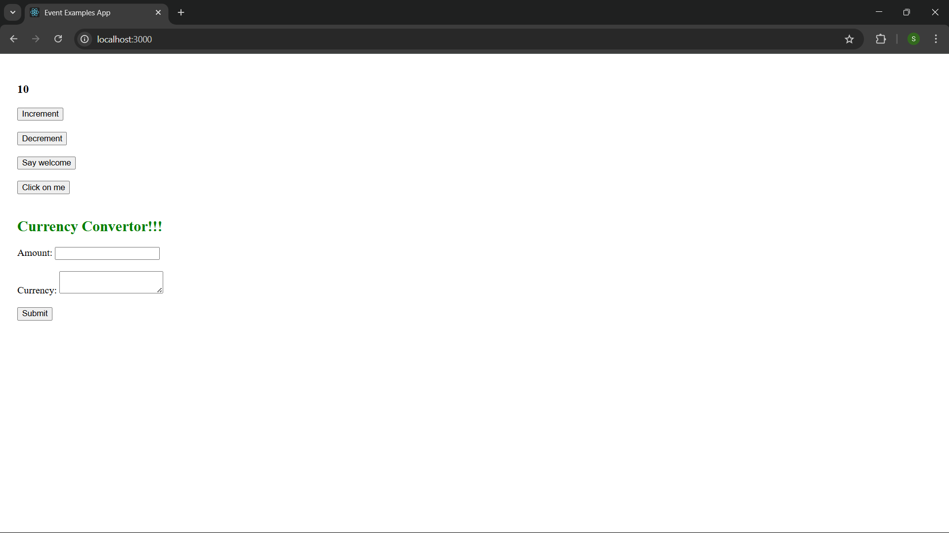

ReactJs-HQL- 20

Create a React Application named “ticketbookingapp” where the guest user can browse the page where the flight details are displayed whereas the logged in user only can book tickets.

The Login and Logout buttons should accordingly display different pages. Once the user is logged in the User page should be displayed. When the user clicks on Logout, the Guest page should be displayed.

App.js

import React, { useState } from 'react';

import Greeting from './Greeting';

import LoginButton from './LoginButton';

import LogoutButton from './LogoutButton';

function App() {

  const [isLoggedIn, setIsLoggedIn] = useState(false);

  const handleLoginClick = () => {

    setIsLoggedIn(true);

  };

  const handleLogoutClick = () => {

    setIsLoggedIn(false);

  };

  return (

    <div style={{ padding: "20px" }}>

      <Greeting isLoggedIn={isLoggedIn} />

      {isLoggedIn ? (

        <LogoutButton onClick={handleLogoutClick} />

      ) : (

        <LoginButton onClick={handleLoginClick} />

      )}

    </div>

  );

}

export default App;

Greeting.js

import React from 'react';

import UserGreeting from './UserGreeting';

import GuestGreeting from './GuestGreeting';

function Greeting(props) {

  const isLoggedIn = props.isLoggedIn;

  if (isLoggedIn) {

    return <UserGreeting />;

  }

  return <GuestGreeting />;

}

export default Greeting;

GuestGreeting.js

import React from 'react';

function GuestGreeting() {

  return <h1>Please sign up.</h1>;

}

export default GuestGreeting;

index.js

import React from 'react';

import ReactDOM from 'react-dom/client';

import App from './App';

const root = ReactDOM.createRoot(document.getElementById('root'));

root.render(<App />);

LoginButton.js

import React from 'react';

function LoginButton(props) {

  return (

    <button onClick={props.onClick}>

      Login

    </button>

  );

}

export default LoginButton;

LogoutButton.js

import React from 'react';

function LogoutButton(props) {

  return (

    <button onClick={props.onClick}>

      Logout

    </button>

  );

}

export default LogoutButton;

UserGreeting.js

import React from 'react';

function UserGreeting() {

  return <h1>Welcome back</h1>;

}

export default UserGreeting;

Output - -

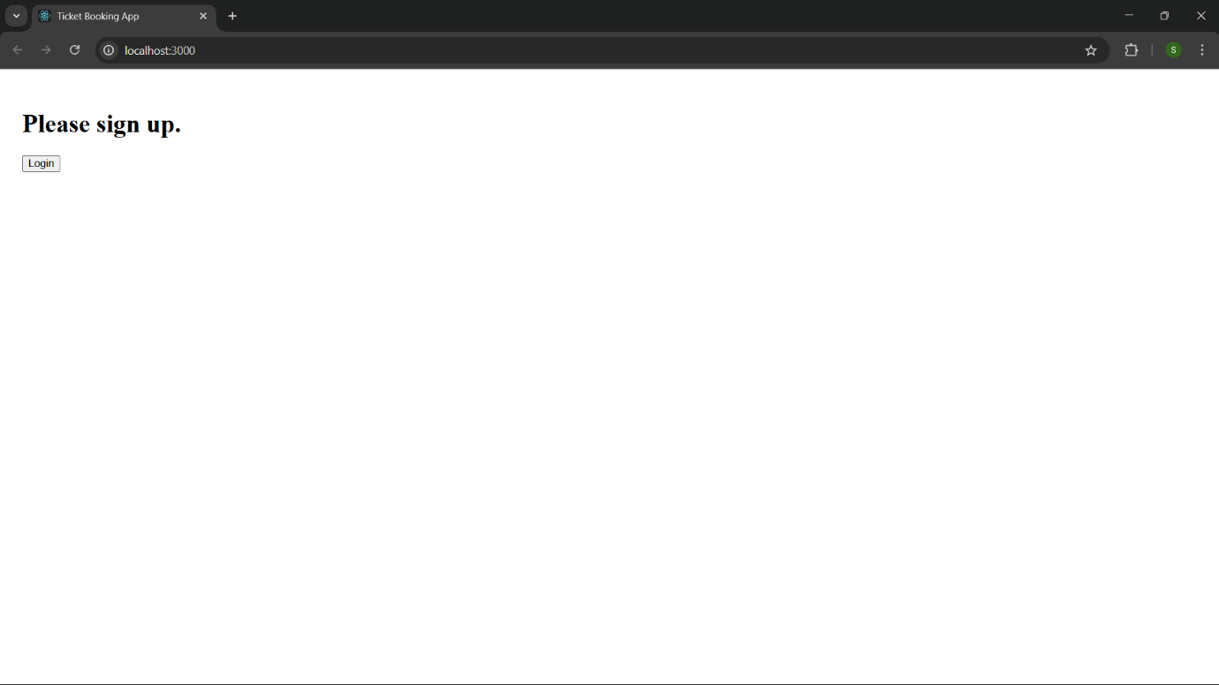

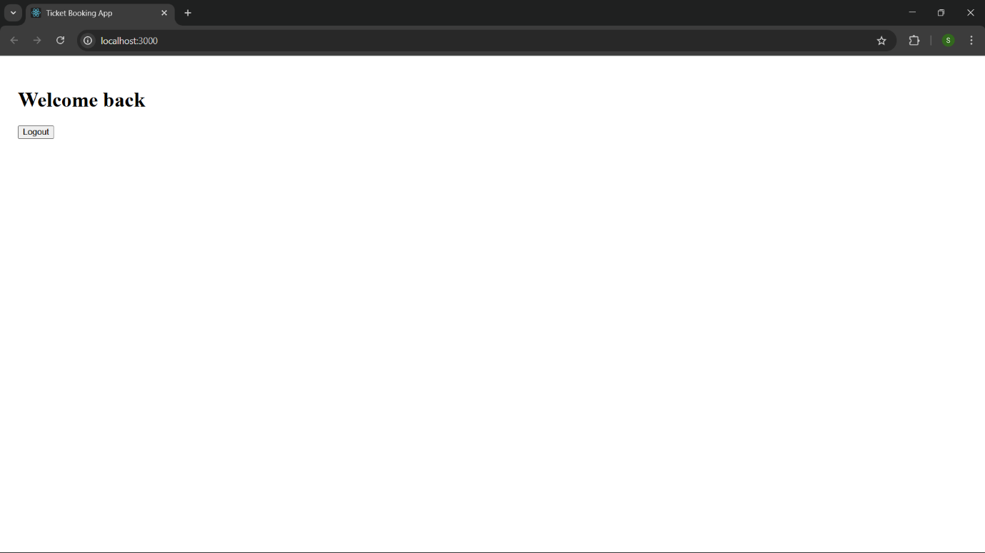

ReactJs-HQL- 13

Create a React App named “bloggerapp” in with 3 components.

1. Book Details
2. Blog Details
3. Course Details

Implement this with as many ways possible of Conditional Rendering.

App.js

import React from 'react';

import BookDetails from './BookDetails';

import BlogDetails from './BlogDetails';

import CourseDetails from './CourseDetails';

function App() {

  const showBooks = true;

  const showBlogs = true;

  const showCourses = true;

  return (

    <div className="container">

      {showCourses && <div className="section"><CourseDetails /></div>}

      {showBooks ? <div className="section"><BookDetails /></div> : <p>No books available</p>}

      {showBlogs && <div className="section"><BlogDetails /></div>}

    </div>

  );

}

export default App;

BlogDetails.js

import React from 'react';

function BlogDetails() {

  const blogs = [

    {

      title: "React Learning",

      author: "Stephen Biz",

      content: "Welcome to learning React!"

    },

    {

      title: "Installation",

      author: "Schewzdenier",

      content: "You can install React from npm."

    }

  ];

  return (

    <div>

      <h2>Blog Details</h2>

      {blogs.length > 0 ? (

        blogs.map((blog, index) => (

          <div key={index}>

            <h3>{blog.title}</h3>

            <strong>{blog.author}</strong>

            <p>{blog.content}</p>

          </div>

        ))

      ) : (

        <p>No blog posts available</p>

      )}

    </div>

  );

}

export default BlogDetails;

BookDetails.js

import React from 'react';

function BookDetails(props) {

  const books = [

    { id: 1, bname: 'Master React', price: 670 },

    { id: 2, bname: 'Deep Dive into Angular 11', price: 800 },

    { id: 3, bname: 'Mongo Essentials', price: 450 }

  ];

  return (

    <div>

      <h2>Book Details</h2>

      <ul>

        {books.map((book) => (

          <div key={book.id}>

            <h3>{book.bname}</h3>

            <h4>{book.price}</h4>

          </div>

        ))}

      </ul>

    </div>

  );

}

export default BookDetails;

CourseDetails.js

import React from 'react';

function CourseDetails() {

  const courses = [

    { name: 'Angular', date: '4/5/2021' },

    { name: 'React', date: '6/3/2021' }

  ];

  return (

    <div>

      <h2>Course Details</h2>

      {courses.map((course, index) => (

        <div key={index}>

          <h3>{course.name}</h3>

          <p>{course.date}</p>

        </div>

      ))}

    </div>

  );

}

export default CourseDetails;

index.css

h2 {

  color: black;

}

.container {

  display: flex;

  justify-content: space-around;

  padding: 20px;

}

.section {

  padding: 10px;

  border-left: 4px solid green;

}

Ouptut—

